Liam Mills

Student iD: 130008961  Supervisor: Snjezana Soltic

115.715 Development Project

# Abstract

This report is focused on showing the progress which has been made towards the Assessment Designer program. It will detail the features which have been implemented, such as the GUI and the different components of the designer section.

Table of Contents

Introduction 1

1. Assessment Designer 2

1.1. GUI 2

1.1.1. Save / Open 2

1.1.2. Recent Files 3

1.2. Building an Assessment 3

1.2.1. Questions 3

1.2.2. Marks 4

1.2.3. Answer Types 4

1.2.4. Text Formatting 4

1.2.5. Export to XML 4

2. Student Side 5

2.1. GUI 5

3. Conclusion 6

# Introduction

This purpose of this report is to show to progress that has been made on the ExamManager project. It will be detailing different parts of the designer, which is near to completion, such as Question creation and management, mark allocation, answer types and saving/loading. It will show the GUI for the designer and student side program, and explain the similarities to the original ExamManager program.

# Assessment Designer

## GUI

I tried to keep the GUI for this project close to the original so that the end user will be able to pick it up and use it easily without having to relearn things. This will help with usability and will keep the program feeling familiar.

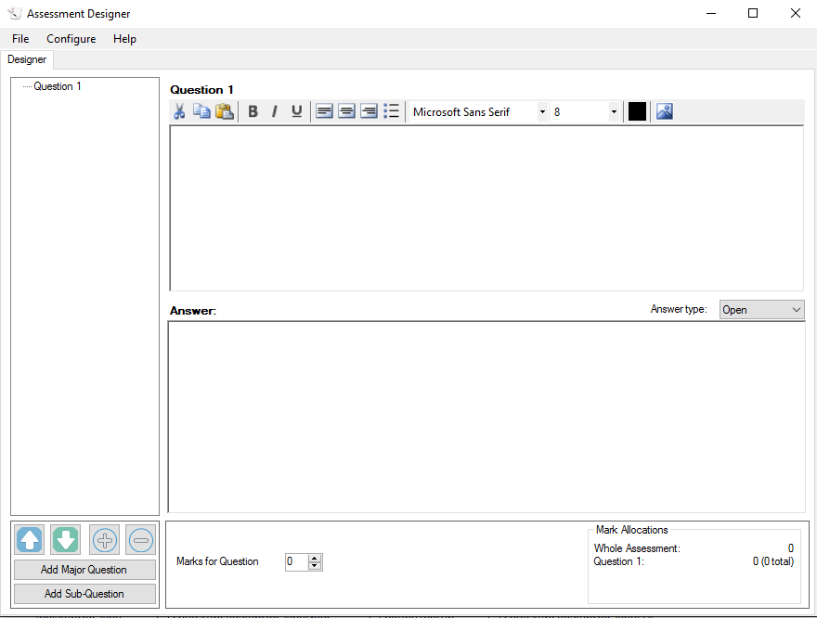

Figure 1 - Designer GUI

As shown in Figure 1, the GUI resembles the original program. The user has a list of questions on the right that they can use to navigate through the assessment. Buttons in the bottom right corner give options to manipulate this list, such as re-ordering a questions up or down, or expand or collapsing all question nodes. The GUI scales to fit the window size, which means it can be changed to a wide range of sizes to fit many different screens. If there is no file opened, then the GUI is disabled to prevent errors from occurring. The user can create a new Assessment by using the option in the File menu, or pressing the keyboard shortcut Ctrl+N.

### Save / Open

The program uses the conventional methods to save and load files. It has Save/Save As and Open options in the File menu, along with the standard keyboard shortcuts. The Save option will only show a SaveFileDialog window if the file has not been saved before. The program detects if changes have been made to the currently open and will display a prompt to the user to save if they try to close it or open a new file. This is to prevent data loss from accidentally closing the assessment before saving.

Still to be implemented is an automatic save feature, which will periodically save the currently open file. It is still to be decided whether this will save to the main file itself, or to a temporary file which will be merged with the main file when the user presses save or closes it.



### Recent Files

Inside the ‘File’ menu, there is an option which lists the last 5 individual Assessment files accessed. This gives the user a quick and easy way to resume their work on an assessment. Whenever the user saves or opens a file, the program looks at the name of the file and checks it against this list of recent files. If it is not contained in the list, then the file is added at the top. If it is in the list already, then it is reordered to the top. Clicking one of the files will open it in the designer. In this way, the program offers a quick way to resume work on an assessment file.



## Building an Assessment

To build an Assessment, there are a number of components which the user can utilize. These all come together to present a functional Assessment which will be run on the program ‘Examinee’ (Name pending).



### Questions

The main parts of an assessment are the questions. As shown in Figure 1, the panel on the right side of the GUI gives the user methods to add, delete and navigate through the questions in the Assessment. To add a question, the user can click the ‘Add Major Question’ or ‘Add Sub Question’ buttons on the bottom right. ‘Add Major Question’ will add a new top level question to the end of the list. ‘Add Sub Question’ will add a sub question to the selected question. Alternatively, the user can right click on an empty space inside the question list panel, or on a question itself. This will open a context menu with options for the user to add or insert questions, as well as delete the selected one if so desired.

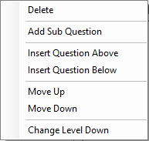

Figure 2 - Question Context Menu

Questions can be reordered up and down in the list and their level in the list can be changed. This gives the user a lot of control over the positions of questions in the assessment and allows them to reorder it easily without having to delete or rewrite questions.

### Marks

Marks can be easily allocated using the NumericUpDown control located at the bottom of the GUI. The overall allocations of these marks are displayed in the bottom left corner of the GUI. This box shows the total marks in the assessment, as well as the allocated marks for the selected question. If the selected question has a parent question, then the marks for that question are shown as well, and the same for that parent’s parent (if it has one). The totals for each question are also shown. These are the sum of all marks for any sub questions that particular question may have, plus its own marks.

### Answer Types

There are four answer types that can be assigned to a question. These determine the type of answer the student is expected to give and sets the correct answer GUI to display on the student side. The four types are:

Open – An open answer question which can be any length.

Single – An answer where the student is expected to give a single word or short sentence as answer.

Multi-choice – The student is given a set of four answers to choose from.

None – A question given an answer type of ‘None’ will not have an answer expected of it. It cannot be allocated any points. This can be used to display a preface or message to the student if the examiner wishes to.

### Text Formatting

The text box where the user writes the questions has a number of formatting options available. For example, the user can use: bold, italic, underline, colour, different fonts and sizes and different alignments. This allows questions to be formatted to improve readability and make the important parts stand out.

### Export to XML

The program can also export the assessment as an XML file if the user wishes to.

# Student Side

## GUI

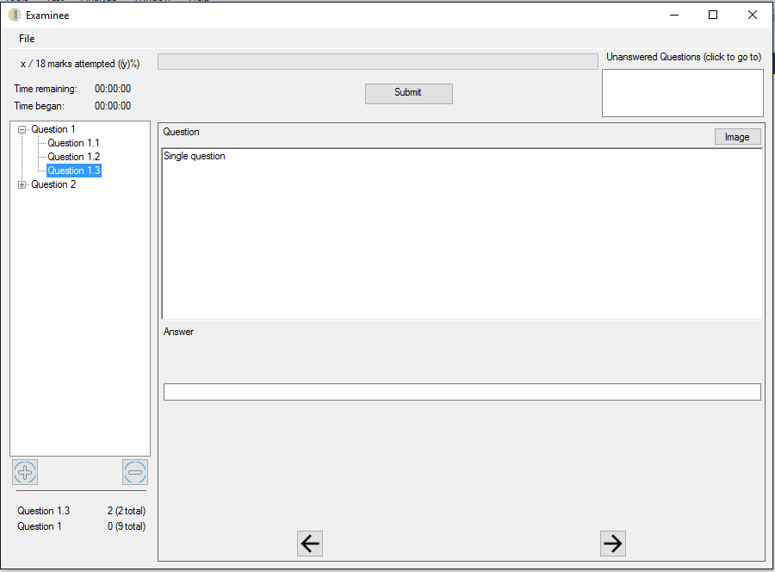

Figure 3 - Student GUI

The student side GUI is also built to resemble the original. This is because, as a user of the previous program myself, it is effective and easy to use. I have made small alterations to the layout but nothing major. I found the original layout effective in how it displayed the information to the user and it was easy to learn and use, and so saw no reason to change it in any major way. However, the layout in Figure 3 is still a work in progress and any changes which can improve it will be implemented.



# Conclusion

To conclude, the program is well under way. Much of the behind-the-scenes framework has been done, which will allow quick development of other parts of it. There are several components which still need to be developed, such as the publishing and marking features, however the library I have been writing contains many functions which will make this easier.